Key Findings
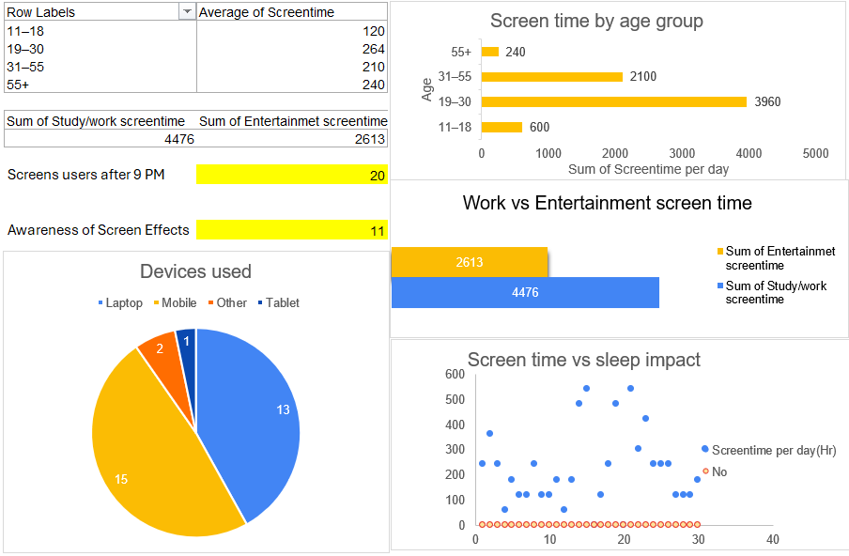
- The average screentime is highest in age group 19- 30
- The maximum screen is used per day in age group 19- 30
- The minimum screen is used per day in age group above 55
- From the data we can see that the most of the screen is used to study/work
- Out of 31 responses 20 people use screen after 9 pm
- Only 11 people thought screen time affect sleep cycle
- The most commonly used devices are Laptop and mobile
Suggestions –
- Try to use hardcopies for study instead softcopies
- Try to avoid screen after 9 pm
- Be aware of health problem due to more screen use

